

**Blizzard**

US Market Procurement

Detailed Process Description

Version 1.2

**Revision History**

|  |  |  |  |
| --- | --- | --- | --- |
| **Date Issued** | **Version** | **Description** | **Author** |
| *04/07/2020* | *1.0* | *Draft* | *NJ, HS, MP* |
| *07/07/2020* | *1.1* | *Draft* | *NJ, HS, MP* |
| *09/07/2020* | *1.2* | *Final* | *NJ, HS, MP* |

**Contributors**

The content of this document has been authored with the combined input of the following group of key individuals.

|  |  |  |
| --- | --- | --- |
| **Name** | **Role** | **Area** |
| *Melissa Potts* | *RPA Consultant* | *QA Ltd* |
| *Nik Jeewon* | *RPA Consultant* | *QA Ltd* |
| *Helena Szwedzinski* | *RPA Consultant* | *QA Ltd* |

**Business Sign-off**

The following table contains the people required to sign-off and/or review this document and those that require the document for information only.

|  |  |  |
| --- | --- | --- |
| **Name** | **Department** | **Responsibility** |
| *Liam Izzard* | *Investment Executive* | *Sign off* |
| *Dave Davidson* | *US Market Procurement Team* | *Information* |
| *Chris Lucas* | *QA Ltd* | *Review* |

**Document Classification**

|  |  |
| --- | --- |
| **Classification** | *Company Confidential* |
| **Definition** | *Information is company confidential and needs to be protected* |
| **Context** | *Where loss of information confidentiality would result in significant harm to the interests of the Organisation, financial loss, embarrassment or loss of information* |

Contents

1 Introduction **4**

2 Manual Process **4**

2.1 Overview 4

2.2 Detailed Process Flow 5

3 Automation Proposal **6**

3.1 Overview 6

3.2 Automated Process Flow 7

3.3 Target Systems & User Requirements 7

3.4 Impacted Business Areas 8

3.5 Workload 8

3.6 Operational Constraints 8

3.7 Delivery 9

3.8 Contact List 9

4 Automation Details **10**

4.1 Automation Walkthrough 10

4.1.1 Get list of companies to research 10

4.1.2 Gather company data 11

4.1.3 Manipulate gathered data 12

4.1.4 Create daily report 14

4.1.4 Deliver daily reports 14

4.2 Reporting 15

4.2.1 Business Exceptions 15

4.2.2 System Exceptions 15

4.2.3 Performance 15

4.2.4 Triggers 18

# 1 Introduction

*The procurement manager at Blizzard Entertainment is keeping their eye out for new ventures or potential investments that they may be able to add to their portfolio from the US Market. The team currently spends more time researching stock exchanges for any new potential investments, rather than using their time analysing whether said investment would be beneficial for Blizzard.*

*QA consultants have been brought in to attempt to reduce the amount of time the procurement team spends on gathering and representing data for potential new investments.*

# 2 Manual Process

## 2.1 Overview

*Overview of the manual process as it stands currently. Includes bullet pointed list of high-level steps to take to run the process.:*

* *Step 1 - Mid-morning Email received from Investment Executive detailing potential investments*
* *Step 2 - Database amended with new companies to monitor / old companies to remove*
* *Step 3 - Using Company Database as a guide, gather stock/share information*
* *Step 4 - Navigate to US Stock Exchanges (Nasdaq, New York Stock Exchange)*
* *Step 5 - Scrape relevant data to monitor stock/shares (change %, high, low etc)*
* *Step 6 - Format the information into graphical format*
* *Step 7 - Create Daily Report in PDF format*
* *Step 8 - Briefly analyse the Report Data and error check*
* *Step 9 - Report is sent daily to Investment Executive at close of play for review the following morning.*

*Acronyms – (NASDAQ) National Association of Securities Dealers Automated Quotations.*

## 2.2 Detailed Process Flow

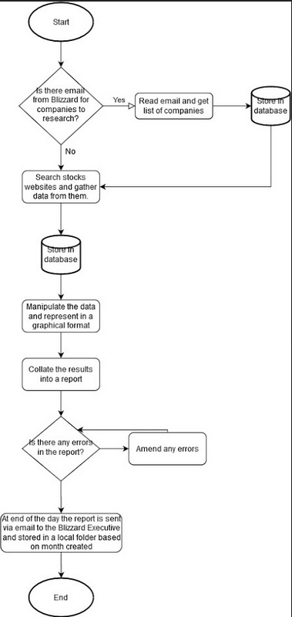

# 3 Automation Proposal

## 3.1 Overview

*Overview of the proposed automated process:*

*The automation is triggered every hour on the hour starting at 11am, with the final run triggering at 6pm.*

*Before 5pm the following is ran:*

* *Workflow 1 - Get List of Automation to Research:*
  + *Step 1 - Read email received from upper management containing companies for potential investments*
  + *Step 2 - Add companies to list*
  + *Step 3 - Create daily workbook*
  + *Step 4 - Add companies to individual sheets on the daily workbook*
  + *Step 5 - Add company list to orchestrator queue*
* *Workflow 2 - Gather Company Data*
  + *Step 1 - Retrieve each company from orchestrator queue*
  + *Step 2 - Navigate to US Stock Exchanges (Nasdaq, New York Stock Exchange)*
  + *Step 3 - Scrape relevant data (open, high, low, close, price, change, change percentage)*
  + *Step 4 - Add data to individual company sheets*

*After 5pm the following is ran:*

* *Workflow 3 - Manipulate Gathered Data*
  + *Step 1 - Convert data into data table*
  + *Step 2 - Create Price graph*
  + *Step 3 - Create Change graph*
  + *Step 4 - Create Change Percentage graph*
* *Workflow 4 - Create Daily Report*
  + *Step 1 - Save each company sheet as a PDF*
  + *Step 2 - Store to local folder*

*After 6pm the following is ran:*

* *Workflow 5 -* 
  + *Step 1 - Searches for current days daily reports*
  + *Step 2 - Attaches to email*
  + *Step 3 - Deliver email to Investment Executive*

*Acronyms – (NASDAQ) National Association of Securities Dealers Automated Quotations.*

## 3.2 Automated Process Flow

Automation mimics the manual process, however, it is important to note that:

* The data will be scrapped and added to a dynamic database every hour
* The data will then be formatted into a graphical format with emphasis on regular information changes throughout the day

## 3.3 Target Systems & User Requirements

|  |  |  |
| --- | --- | --- |
| Name | Description | User Permissions/Access |
| *MS Outlook* | *Email Inbox* | *Robot inbox required - For automation purposes:.*  [*robotrpa66@outlook.com*](mailto:robotrpa66@outlook.com) *will simulate US Market Procurement Manager’s email address.*  [*mpotts@academytrainee.com*](mailto:mpotts@academytrainee.com) *will simulate Investment Executive’s email address.* |
| *Chrome Web Browser* | *Web Browser* | [*https://www.nasdaq.com*](https://www.nasdaq.com)  [*https://www.nyse.com/index*](https://www.nyse.com/index) |
| *MS Excel* | *Database Application* | *Permission to access:*   * *Daily Company Stock Workbook* * *Folder containing all Daily Company Stock Workbooks.* |
| *Graphing Software* | *Graphing Software* | *Graphing Software* |
| *Foxit Reader* | *PDF Reader to view daily reports.* | *Foxit Reader* |

## 3.4 Impacted Business Areas

* *US Market Procurement Department*

## 3.5 Workload

|  |  |
| --- | --- |
| *Max. no. of potential investments Blizzard monitor* | 20 |
| *Min. no. of potential investments Blizzard monitor* | 5 |
| *Average no. of potential investments Blizzard monitor* | 10 |
| *Are there any periods when a higher workload is anticipated?* | Whenever there are big gaming and technology events, such as E3, Tokyo Game Show and Insomnia. Also when there are big product announcements such as next gen console releases. |
| *How many people do this process per day?* | *1* |

***Automating the steps below will realise an average time saving of 550 minutes (~ 9 hrs) per day for US Market Procurement process:***

* *Amending list of companies to research (10 mins)*
* *Gathering stocks data on each company and inputting that into a database (30 mins per company)*
* *Analysing and graphing the data (3 hours)*
* *Writing the daily report and proofreading (1 hour)*

## 3.6 Operational Constraints

* *Email from Executive manager detailing the companies to research is typically received before 11am daily*
* *Working day is from 9am until 6pm*

## 3.7 Delivery

*A minimum viable product will be expected by the 10/07/2020.*

## 3.8 Contact List

*Blizzard Entertainment - Executive - Liam Izzard*

*Blizzard Entertainment - Procurement Manager - Dave Davidson*

*QA Ltd - RPA Consultant - Helena Szwedzinski*

*QA Ltd - RPA Consultant - Melissa Potts*

*QA Ltd - RPA Consultant - Nik Jeewon*

*QA Ltd - RPA Project Liaison - Chris Lucas*

# 4 Automation Details

## 4.1 Automation Walkthrough

### 4.1.1 Get list of companies to research

* Read in emails from (email client) inbox and filter for (correct subject)

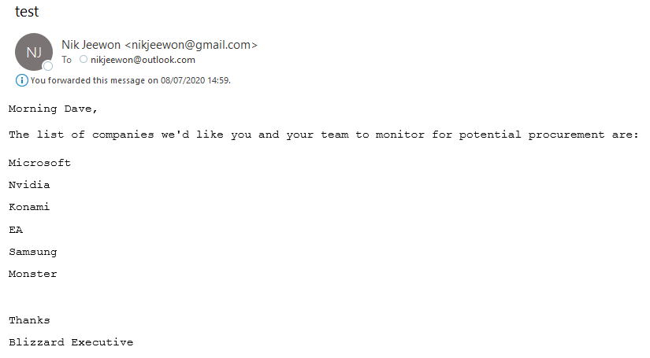

* Filter the email for Company Names, using double split within String manipulation
* Add Companies to Date Stamped Excel Workbook



* Ensure each Company creates a new Sheet in Workbook



* Read the Workbook file and use the Sheet Names to add individual items to an Orchestrator Queue

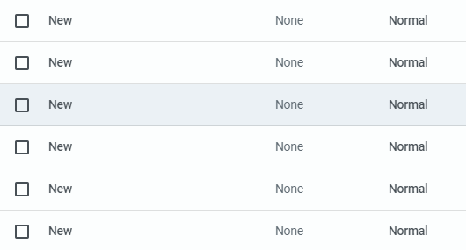

### 4.1.2 Gather company data

* Build the stocks data table where data will be written to. It will have the following columns: Time (hh:mm:ss), Share Volume, High Price ($), Low Price ($), Open Price ($), Current Price ($), Close Price ($), Change (%) and Change ($)
* Open google chrome browser on the google homepage
* Set the current time
* Navigate to the New York Stock Exchange (NYSE) listings directory at https://www.nyse.com/listings_directory/stock

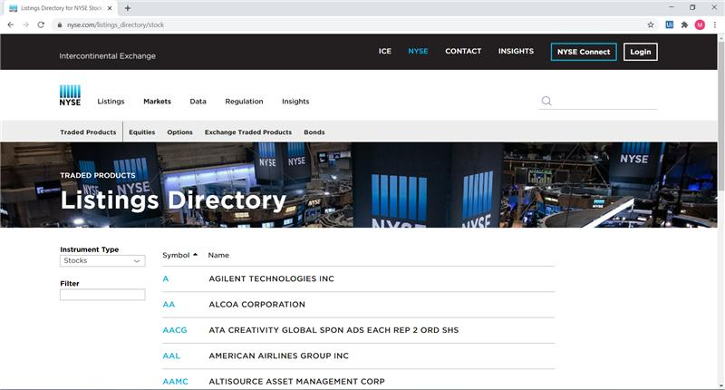

* Search for the first company in the list in the search bar on the NYSE listings directory.
* Navigate to the page with that company's stocks data and scrape the data items that are required.
* if there is no data or there are no search results for that company then navigate to the Nasdaq stock exchange website:

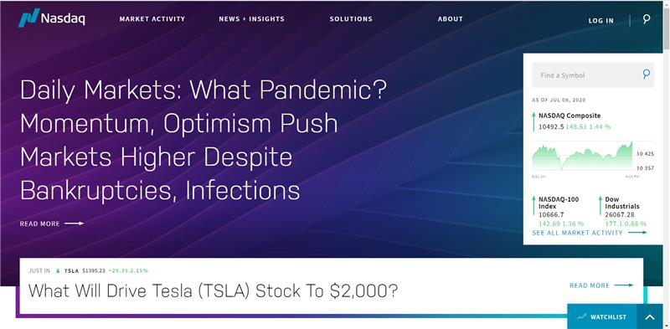

* + search for the company in the search bar and navigate to the web page that has that companies data
  + Scrape all the required data
  + If there is no data or there are no search results for that company then EXCEPTION
* Write the scraped data to an excel file, where the sheet it is being written to is named after the company that the data was scraped for
* Repeat this process for all companies

### 4.1.3 Manipulate gathered data

* *Formats gathered data into data table*
  + *Selects all gathered data*
    - *If no data has been gathered → Skip current company sheet & continue with next company sheet*
    - *Else → Convert data into a data table*

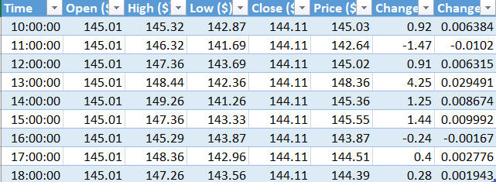

* *Initialise Graph Type*
  + *Create a generic graph from data table.*
  + *Change chart type to ‘Line with Markers’*
* *Create Price Line Graph*
  + *Add Correct Data*
    - *High Price ($)*
    - *Low Price ($)*
    - *Current Price ($)*
  + *Rename graph to ‘Price ($)’*
  + *Reposition graph under data table*
  + *Resize graph to 16.5cm to maximise fit on A4*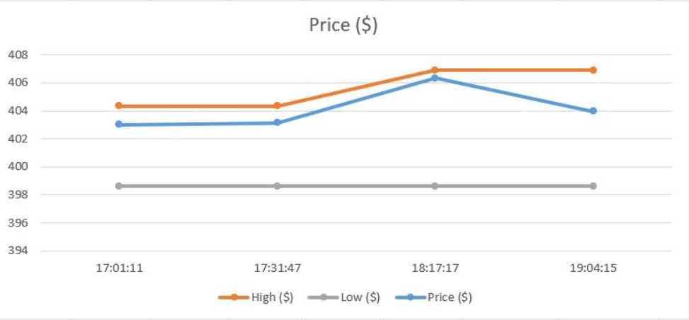
* *Create Change ($) Graph*
  + *Add new graph*
    - *Using format from above graph*
    - *Reposition graph under previous graph*
  + *Rename graph to ‘Change ($)’*
  + *Add Correct Data*
    - *Change ($)*
* *Create Change (%) Graph*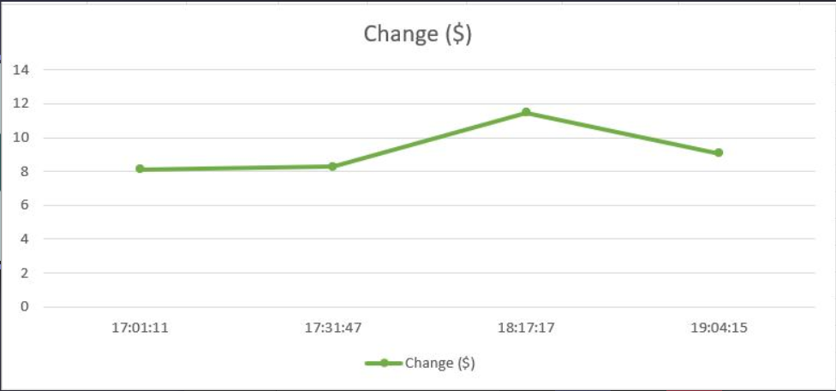
  + *Add new graph*
    - *Using format from above graph*
    - *Reposition graph under previous graph*
  + *Rename graph to ‘Change (%)’*
  + *Add Correct Data*
    - *Change (%)*

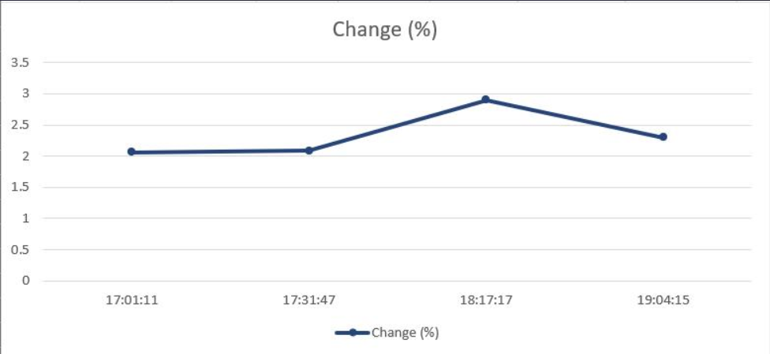

### 4.1.4 Create daily report

* *Export company graph sheet as PDF*
  + *Save under name: current date & company name*
    - *eg. ‘DDMMYYYY COMPANYNAME’*
  + *Export company graph sheet as PDF in local folder*
    - *Save under name: current date & company name*
      * *eg. ‘DDMMYYYY COMPANYNAME’*
    - *Save as PDF*

### 4.1.4 Deliver daily reports

* *Search within local folder for all of current days company daily reports*
  + *If file name contains current days date → select file*
  + *Else → skip file*
* *Attach all selected reports to email*
* *Send delivery email to Investment Executive using report delivery template*

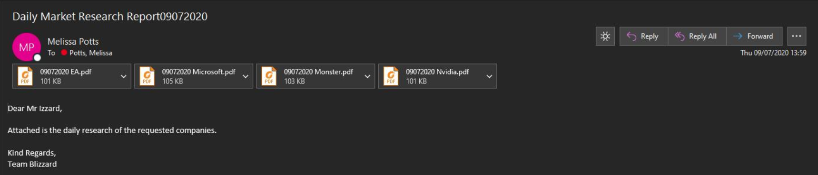

## 4.2 Reporting

### 4.2.1 Business Exceptions

|  |  |
| --- | --- |
| *Exception* | *Solution* |
| *No data gathered for a specific company* | *Include in the report all companies that the automation was unable to gather data for due to data not being available on the specified stock exchanges.* |
| *No graphs could be created for a specific company due to data not being available.* | *Note in the report the companies that there was no data for.* |
| *PDF file could not be created* | *Report in log that PDF was not created.* |

### 4.2.2 System Exceptions

|  |  |
| --- | --- |
| *Exception* | *Solution* |
| *Orchestrator is unavailable* | *Pause the automation for an hour and try again* |

*A performance log will be available on the company's instance of orchestrator via the log and queue items.*

### 4.2.3 Performance

***Performance Log***

*The performance log details during the automation including high level steps, transaction status’, info, warnings, errors and fatal actions.*

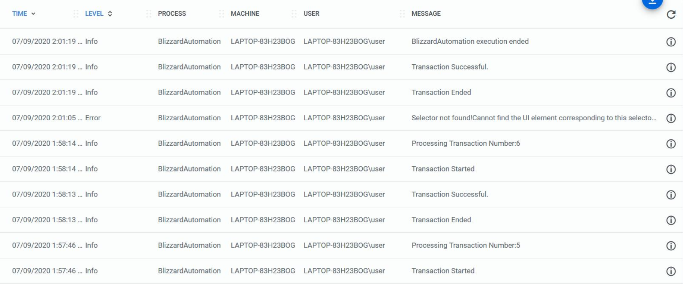

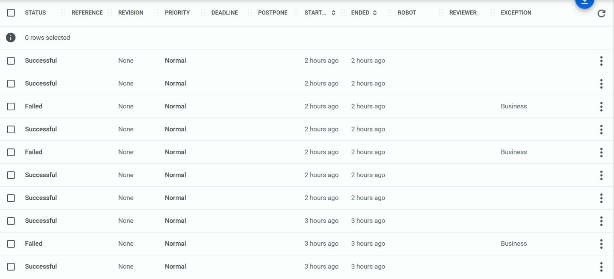

***Daily Company Stock Report***

*After completion several Daily Company Stock Reports will be created in PDF format showing all the collated data & graphs created for each company passed through.*

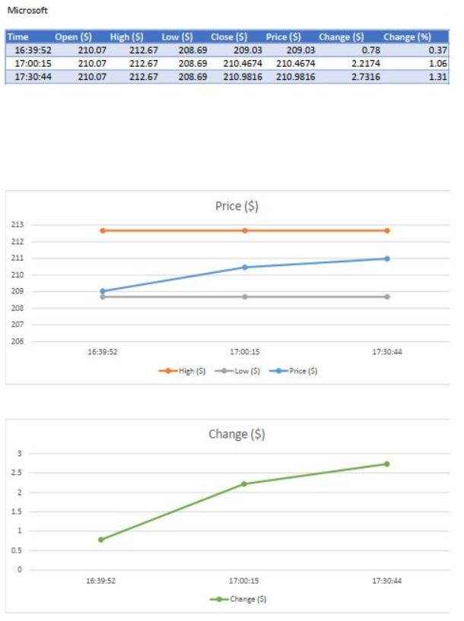

### 4.2.4 Triggers

*The robot will be triggered every morning at 11am using the UIPath Orchestrator. This will then read in the emails to get the company list and then start gathering stocks data for each company. Then at the end of the working day (5pm) the robot will begin the reporting process, where it will produce a daily report based on the data gathered that day. If it is the end of the week the robot will also produce a weekly report based on the data gathered over the past week.*